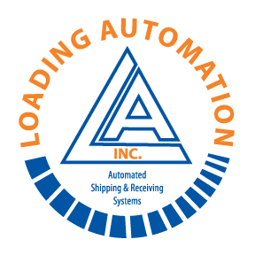 | LOADING AUTOMATION, INC.  P.O. BOX 4820  WILMINGTON, NC 28406  TEL. 910-791-2125  FAX 910-452-3889  E-MAIL: parts@loading-automation.com |  |   PARTS RETURN FORM  (MUST BE COMPLETED TO RECEIVE CREDIT)
Date: ___/___/___ |  | Employee# Requesting Return: |  | Original Invoice #

FedEx Facility & Address | Order Details | Ship to Address
 | Cost Center # | Loading Automation Inc.
 | Project (Facility ID) # | 3310 Enterprise Dr.
 | G.L. Acct. # | Wilmington N.C. 28405
 | Employee #
Contact: | Vehicle Asset #
Phone # | Vehicle ID # | Attn: Parts Department
Fax # |  | P.O. or Reference #

Part # | Description | Orig. Qty Shipped | Qty Being Returned | Invoiced  Unit Price | Total

Reason for return :  - wrong part ordered  - wrong part shipped  - failure in service  - damaged upon receipt  - quantity over shipment | Return Comments:
Parts Returned To LAI ?  YES NO | * Note * All Returns Subject To Final Approval by Loading Automation Inc.
Parts Returned To LAI ?  YES NO | Ship Via: | Shipping Acct#

Tracking Numbers : | Pkgs | Lbs (#) | Dimensions | Value
 | Pkg#1
 | Pkg#2
 | Pkg#3
Return Authorization Approved By _____________________________ | Return Authorization Number:

